Field Task Manager Invalidate Task to Task Manager
Object Sequence Diagram

@startuml
Participant “Field Task Manager” as FTM
Participant “Task Manager” as TM
FTM -> TM: InvalidateTask(TM Task Id)
TM -> TM: Invalidate Task
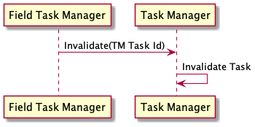
@enduml

